Name: Peter Tran

PID: A11163016

cs11ehc

User Guide HW7

In this homework assignment our job was to take 2 excel files (.xlsx) which each had a stock inventory and update the original sheet with a vendor sheet and output the file into a user selected area. Both the master and vendor sheet should have columns labeled with MAP and SKU so that the items can be updated. The final output will be saved in the user's desired folder location with a new file titled "updatedMaster.xlsx" that will contain the new updated data. By utilizing GUI and the Apache POI, I was able to successfully compile and run this program.

How to:

Before we being, you must be able to compile and run this program. To compile this program and then run, use the following commands:

javac –cp “/home/linux/ieng6/cs11e/public/HW7_libs/*:.” HW7.java

java –cp “/home/linux/ieng6/cs11e/public/HW7_libs/*:.” HW7

1. Start off with an original file, we'll call this the master file, with this format, where we focus on the SKU (Stock Keeping Unit) and MAP (Minimum Advertised Price):

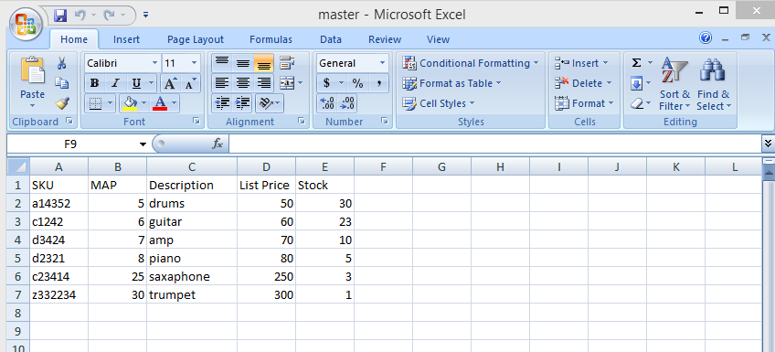

If you don't choose an .xlsx file, you will be prompted to choose the correct file type:

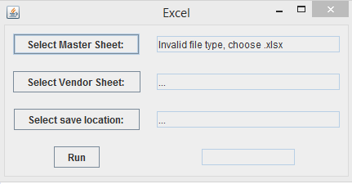

Similarly, if you choose a .xlsx file that does not have the correct file format, you will be prompted to choose a .xlsx file with the correct file format:

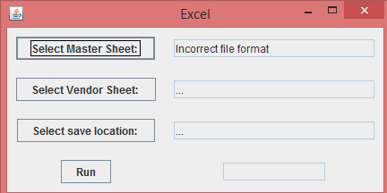

2. Select the master file by pressing the "Select Master Sheet" button (Note: After you select the correct file and press okay, the text field next to the button will be updated with the file location) :

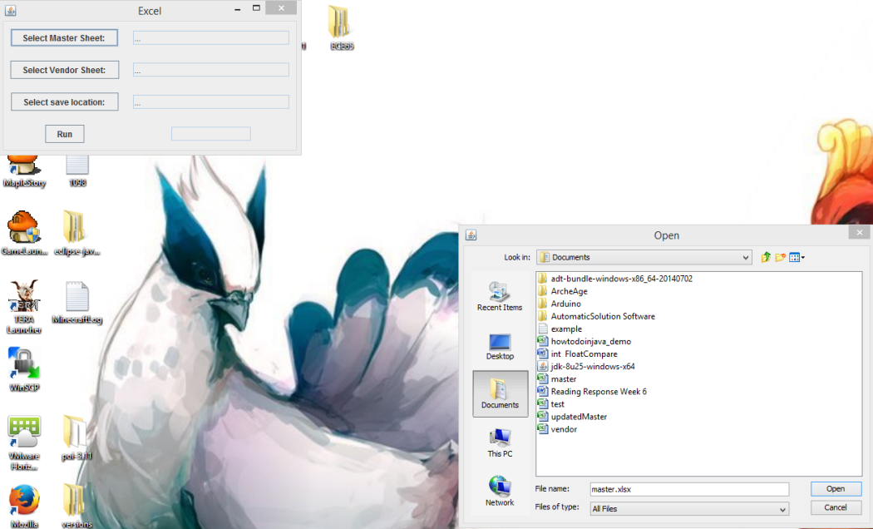

Just as in step 1, choosing the incorrect file types will result in a prompt for the user to reselect the correct file type/format:

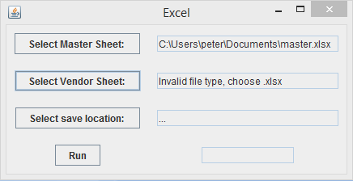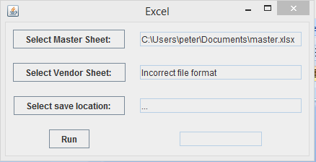

3. Select the vendor file, or the second file that will be used to update your master sheet, by pressing the "Select Vendor" button:

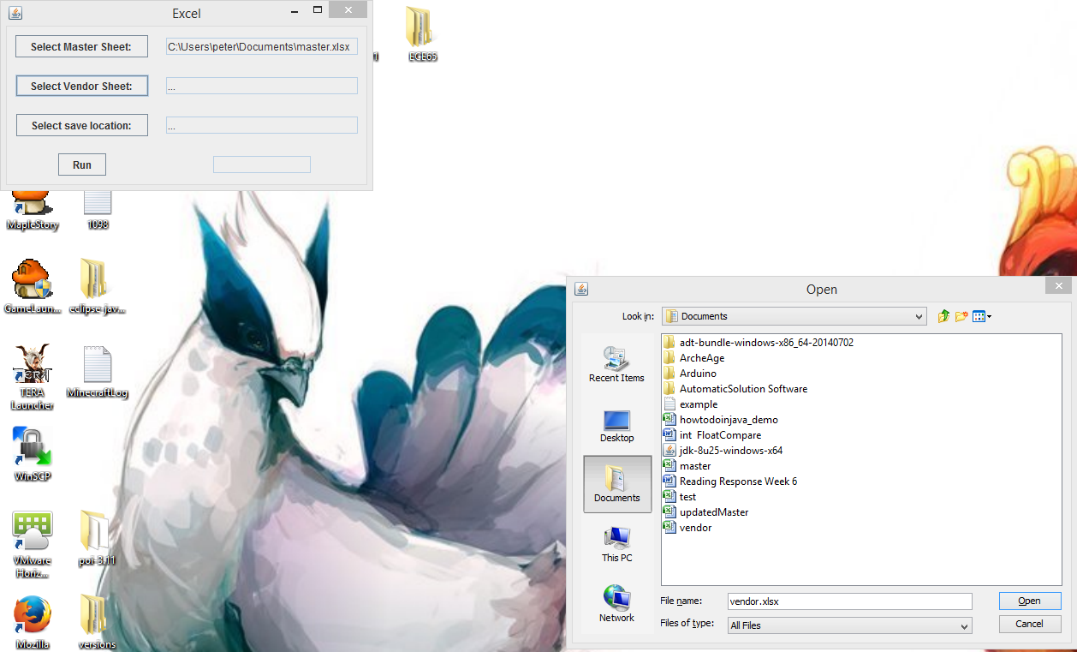

4. Select the "Select save location" button to choose where you want to save the new updated sheet (Note: This will be a directory you select):

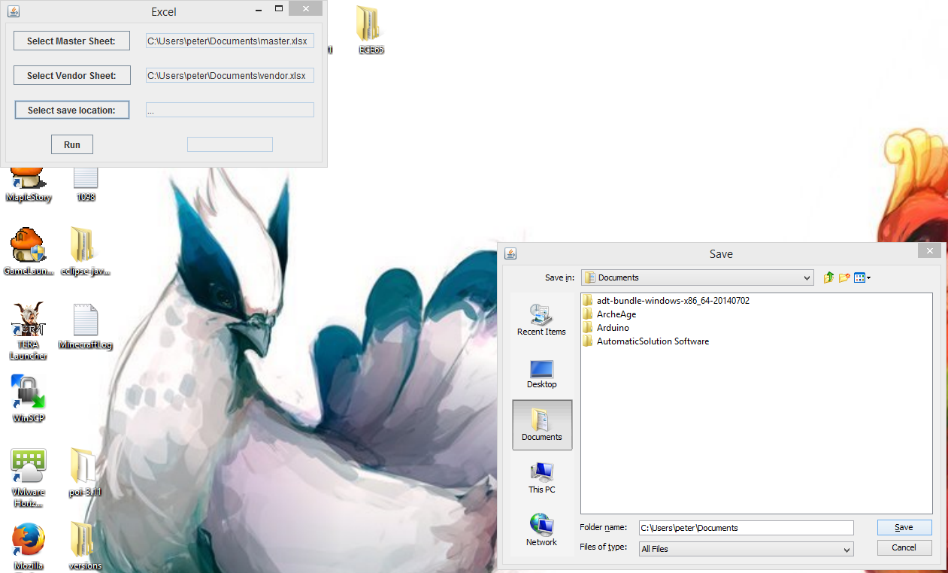

If the user did not select a master or vendor file or left both fields empty, the user will be prompted to select and fill the corresponding areas:

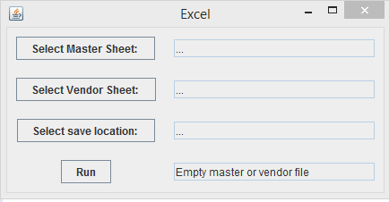

If no output location was chosen, the user will be prompted to select a directory to save the file in:

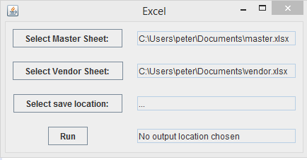

5. Press the "Run" button and the text field next to it will update to "Complete" when the program is done running (Note: The output will be generated as a new file called updatedMaster.xlsx in the chosen directory):

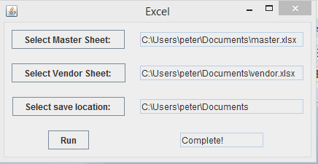

Your final output should have 2 sheets, the first with the original and the second with the updated content:

Original Sheet:

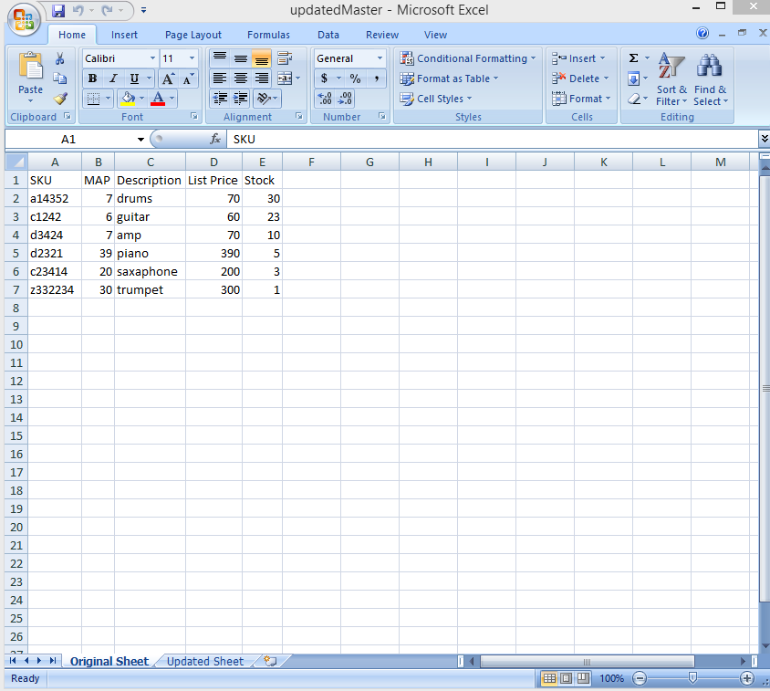

Updated Sheet:

